|  |  |
| --- | --- |
| **ILDP** **SYNDICATE 4** **ALP 100% SUBMISSION** | An analysis of new international competitors in the SA retail sector: implications for SA retailers and possible responses |
|  |  |
| 11/20/2015 | MISSION STATEMENT |
|  | We aim to leverage our learning’s to positively influence and impact the wholesale and retail sector through integrity and objectivity. |

TABLE OF CONTENTS

1. **Team Rockets**
2. **Introduction**
3. **Business Problem or Opportunity Area**
4. **Objectives & Scope of Project**
5. **Research Methodology**
6. **Discussion of Results**
7. **References**

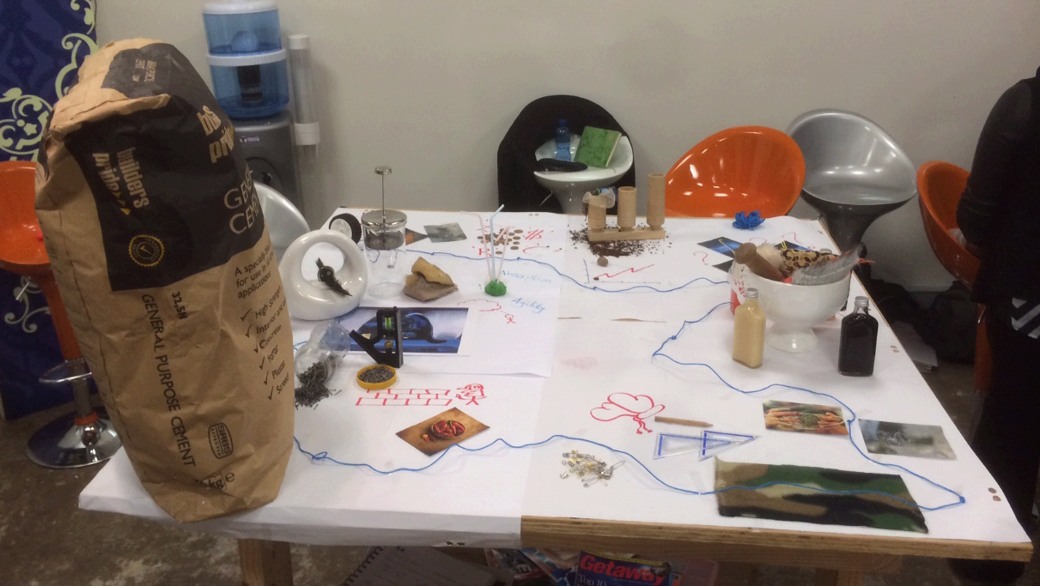

TEAM ROCKETS:

|  |  |
| --- | --- |
| **Bilal Kardame** |  |
| **Denzil Poovan** |  |
| **Ntutuko Hlengwa** |  |
| **Olivia Rungasamy** |  |
| **Trevor Govender** |  |
| **Tryphosa Malatsi** |  |

# Introduction

The Retail Sector is a fast-paced, highly competitive industry that comprises of a number of businesses and organizations that ply their trade through the selling of goods and services to consumers. The businesses within the retail sector are easily distinguishable from other businesses in other sectors by how and where they trade. These businesses trade predominantly within shopping malls, in department stores, as discount stores, and specialty stores whilst some even trade seasonally.

The South African retail industry has grown over the past few years, and this growth has been bolstered by an increase in both the supply of retail space and increase in the number of shopping centre’s around the country. Over the last eight years this industry has grown by an annual average of 3%, which has subsequently lead to the growth in sales of an annual average increase of 29% in online retail sales, with projections of further escalations in total retail sales over the next few years. Such growth is attributed to the favorable local economic conditions for consumers; exemplified by the low level of the interest rate; inflation and economic growth.

The South African retail environment is highly developed and with a modern consumer base. The African Retail Development Index, developed by AT Kearney, highlights how significant the retail industry is to the South African GDP. South Africa has one of the highest GDPs on the continent with the retail sector accounting for 14.3% of it and boasting the highest consumer spending. Over the period 2005 to 2012, it can be seen that the South African retail sales has grown steadily by roughly 3%, which is mainly attributable to low inflation and interest rates, coupled with stable macroeconomic conditions in the country. The South African retail market has a consumer base driven by a growing middle class with a strong weighting on brand and price in their purchasing decisions. With such an established retail landscape coupled with a consumer base that is showing increasing internet penetration, the popularity of E-Commerce is on the rise as consumers strive for convenience and price. [1]

## Key Concepts

Retail can be defined as being the process of selling goods or services to customers through various distribution channels all with the objective of earning a profit. The classifications from the Standard Industrial Classifications (SIC), courtesy of Statistics South Africa (Stats SA) can also be used to define the retail trade industry. The retail trade industry falls under section 62 of the SIC. This industry is also said to be inclusive of the reselling (sale without transformation) of new and used goods to the general public for personal or household consumption or use by shops, department stores, stalls, mail order houses, hawkers and peddlers, and consumer cooperatives. Businesses that are classified under this division include amongst others, those that sell to the general public, from retail products such as type writers, stationery, paint or lumber. Stats SA have elaborated further on the definition of this industry by reporting that the retail industry forms part of the major trade division which includes wholesale & retail trade, repair of motor vehicles, motor cycles, personal & household goods and hotels & restaurants.[2]

The retail industry consists of 7 clusters, which are:

• General dealers;

• Retailers of food, beverages and tobacco in specialised stores;

• Retailers in pharmaceutical and medical goods; cosmetics and toiletries;

• Retailers in textiles, clothing, footwear and leather goods;

• Retailers in household furniture, appliances and equipment;

• Retailers in hardware, paint and glass; and

• All other retailers

The retail industry in SA as represented by the listed clusters above has grown from strength to strength over the years and has been a beneficiary of the South African economy transition to become a consumer driven economy. The decline of the mining and manufacturing sectors over recent years has also supported the notion that the industry expansion falls in the hands of retailers.

The clusters as listed above therefore represent a significantly broad section of the industry, and in order to narrow the scope of research this report will therefore focus on two of the 7 clusters.

Namely:

1. Retailers in food, beverage and tobacco;
2. Retailers in textiles, clothing, footwear and leather goods.

The selected clusters are an integral part of the retail industry in South Africa and boasts of a number of large holding companies that account for more than 80% of local retail sales. Many of the international competitors that have begun to trade in South Africa, or signaled their intentions to do so also operate under this cluster. It is for these reasons that these clusters has been selected as the one to assess.

## Definition of International Competition

When dealing with the definition of international competitors, it soon becomes apparent that this could be defined in any number of ways ranging from the ownership of such companies, the licensing/franchise agreements of specific companies and/or brands, and the geographic positioning of the headquarters of these companies. Defining this concept is, as a consequence, not without complication and can be the source of much debate; however for the purpose of this project we have opted to limit our definition to a set of criteria.

The criteria to be used in defining international competition are that of retail companies that operate in the retail sector outside the borders of its country of origin with branches that extend into multiple countries, with an ownership of more than 50% and where its revenue generated is taken outside of South Africa.

It is important to note that while this classification may encompass other African countries as being international competitors, the focus of this progress report is largely based on retail companies that originate from developed countries, mostly European, American; Australia and the East. These retail companies are perceived as competitors and rivals to the South African retailer as they not only sell the same goods or services, but are better positioned to make accessible international brands to the South African consumer.

## Background to International Competition

The threat of international competition is not unique to South Africa; in fact you would be hard pressed to find a single country in the developed world where this is not occurring. International competition has been on the rise over the past few years and it is becoming increasingly apparent that there will be no slowdown in the rate at which it is occurring. The retail sector globally has become fiercely competed as international players all strive for driving down costs, increasing market share and searching for untapped markets that could bolster their current performance or propel them into the future. As first world markets become increasingly saturated, international retail brands are constantly looking to emerging markets as a means to diversify and to find new sources of increasing the brand performance.

Reviewing the global retail landscape, emerging markets are the most viable markets to establish a presence, due to the fact that these economies are still being structurally developed, consumer disposable income is on the rise and these economies are producing growth rates that are outperforming first world economies. These factors are a few reasons why global retail brands are actively seeking to establish themselves within these economies. South Africa has been identified as one of these economies that can provide growth and a suitable entry point into the African continent. Currently economic growth rates are outperforming leading global economies and many retail indices are tipping Africa as the retail hotspot for international competitors to establish themselves in.[3]

In 2011, aggregate retail sales surpassed a trillion rands in South Africa for the first time in history. By 2016, this is expected to swell to R1.46tr. Much of this market is dominated by a dozen large holding companies, which collectively own the majority of the country’s biggest brands. The biggest of these – Shoprite, Pick ‘n Pay, Spar and Massmart – account for about 80% of local retail sales, with various sub-brands targeting different consumer segments of the market. Until the entry of Wal-Mart, all of the companies were locally owned.[4]

The South African retail environment is highly developed with a modern consumer base comprising of consumers who are highly informed, techno savvy, impulsive and trendy. The African Retail Development Index, developed by AT Kearney, highlights how significant the retail industry is to the South African GDP. South Africa has one of the highest GDPs on the African continent with the retail sector accounting for 14.3% of it and boasting the highest consumer spending. Over the period 2005 to 2012, South African retail sales have grown steadily by roughly 3%, which is mainly attributable to low inflation and interest rates, coupled with stable macroeconomic conditions in the country. The South African retail market has a consumer base driven by a growing middle class with a strong weighting on brand and price in their purchasing decisions. With such an established retail landscape coupled with a consumer base that is showing increasing internet penetration, the popularity of E-Commerce is on the rise as consumers strive for convenience and price. With a fast growing population and middle class having an interest in differentiated branded product, coupled with South African retailers having established supply chains into many African countries, international retailers have a very compelling reason to enter the South African retail industry.[5]

Expanding internationally allows retailers to tap into a broader sales base, increase their bargaining power with suppliers as they will have a bigger market to service which then results in added benefits and they can leverage current knowledge and systems across more areas. The only drawback to expanding internationally is that as an international retailer enters a new country or market, it is subjected to new cultures, languages, regulations, laws, consumer behaviours, etc. – all of which needs to be taken into account should the retailer want to be successful in the new market.[6]

Mergers and acquisitions provide the best method of obtaining company growth for a retailer as the acquirer gains access to resources far quicker as opposed to establishing itself in the new market on its own. This means that the retailer being acquired will already have stores available, their staff will have key local knowledge to tap into, supply chain infrastructure will exist and all current relationships with vendors will still be maintained.

When international retailers enter a new market, whether it is a traditional setup or an acquisition, the behavior of the established competitors in the market is to always adapt. A study in the Chilean retail sector highlights the strategies that local retailers used to combat the entrance of foreign competitors into the market. Bianchi & Reyes, 2005, highlight the following strategies that were implemented by local retailers to be competitive with foreign entrants into the retail market:

1) Obtained information on the competitors strengths and weaknesses before they entered the market and employed their best techniques

2) strengthened their own retail knowledge and employed a highly skilled management team to execute the strategy

3) Opened stores in strategic locations in order to gain geographical advantages and 4) invested in modern technology and training staff.

These defensive strategies were implemented extremely well within the Chilean market, so much so that it had resulted in a highly competed and professional retail market being established and ultimately resulted in a better retail offering to the consumer.[7] The entrance of international retailers into emerging markets can have a positive effect on the overall retail landscape, as it forces local retailers to improve on their processes, invest more in infrastructure and up skilling the staff compliment. Not only does this help develop the local retail industry, but it also provides great benefit to the end consumer due to increased levels of professional competition.

A study of this phenomenon is therefore not only interesting, but is also a necessity in order to fully understand why international competitors have targeted SA as a country to trade in, along with a look into the implications this will have on the South African Retailers (SAR) and any possible responses the SAR might have.

## Background to Country Competiveness

We have explored the notion of country competitiveness in an attempt to determine South Africa’s response to foreign retailers wanting to expand into the South African market and have found that the theories relating to the competitiveness of a country remains varied, however, we have selected three noteworthy concepts and have detailed them below; these include:

1. The World Bank trade competitiveness toolkit[8]
2. World Economic Forum global competitiveness index
3. Michael Porter’s country competitiveness theory

The toolkit developed by The World Bank provides a framework, with guidelines and practical tools required to conduct an analysis of the trade competitiveness of a country. The toolkit has been used to assess competitiveness of various sectors within a country and ultimately representing the competitiveness of a country.

In its most recent publication, South Africa Economic Update (2014); The World Bank identified three areas which can be pursued to achieve a more competitive South Africa. These focus areas include[9]:

1. Boosting domestic competition, this would result in an increase in efficiency and productivity within the local market.
2. Promoting deeper regional integration in goods and services, primarily targeting African markets and creating a Southern African manufacturing base.
3. Alleviating infrastructure bottlenecks, especially in power, and removing distortions in access to pricing of trade logistics in rail, port and ICT’s would reduce overall domestic prices and further enhance competitiveness.

The South African government has embarked on policies which seek to address these and other issues, these policies include the National Development Plan 2030 and the New Growth Path (2011). Successful implementation of these policies will result in areas identified by the World Bank being comprehensively addressed, ultimately improving South Africa’s competitiveness.

The World Economic Forum (WEF) publishes a global competitiveness index on an annual basis; the 2014-2015 addition covers 144 countries. The index attempts to rank countries based on its competitiveness. The WEF defines competitiveness based on a countries institutions, policies and factors that determine the level of productivity.

In its most recent ranking, South Africa had dropped 3 places to be ranked 56 out of 144 countries on the WEF global competitiveness index. A mixed bag of positives and negatives resulted in South Africa dropping in the competitive stakes. We have listed some of the reasons for the drop in ranking and have highlighted some of the countries responses below:

* High unemployment, especially youth unemployment
* Workforce health
* Higher education and training
* Weak economic growth

In an effort to address these issues, the following initiatives have been implemented:

* Youth wage subsidy for the employment of youths
* Health care programs seeking to manage and prevent communicable diseases
* Building of new universities and upgrading of current universities
* Policy intervention to stimulated growth, development of special economic and/or industrial zones

It is imperative that South Africa remains competitive in an effort to attract foreign capital which would afford development of the local economy and ultimately local companies. South African companies would subsequently then be able to export goods and services abroad, competing globally, whilst being better equipped to compete locally with foreign entrants in the market.

In a recent publication, Brand South Africa stated the importance of the WEF and provided reasons for South Africa to improve its ranking; these included:

* Market our country as open for business in key sectors, ultimately exporting South African goods and services to other economic regions
* Stimulate growth within the local economy
* Attract investors seeking opportunities in developing markets

The third theory explored is the Michael Porter’s competitive theory and diamond model. Porter’s analysis suggests how a nation becomes competitive; the diamond model as depicted below highlights the key components of Porter’s model.

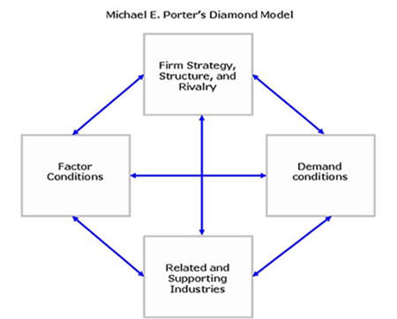

Recklies (2001) provides the following analyses relating to the Diamond Model:[10]

1. Factor conditions deal with production factors, the availability of skilled labour and infrastructure
2. Demand conditions evaluate a countries demand for the goods and services produced within the country. These conditions have a direct impact on a countries ability to innovate and enhance product development
3. Firm strategy, structure and rivalry highlight the conditions required to establish and manage a business within a specific country
4. Related and supporting industries, determines the existence of internationally competitive supporting industries within a country

Porter’s theory ultimately frames competitiveness to mean one thing and that is, that a countries competitiveness is determined by its productivity.

In South Africa, various public and private initiatives are underway to improve the competitiveness of organizations and primarily improving our countries competitiveness.

These initiatives include Productivity SA[11], an organization that assists individual organizations with improving operational productivity with their primary mandate being to enhance productivity within South Africa and also the South African Competitiveness Forum, which is an initiative by Ernst and Young and Branch South Africa[12] which promotes a collaboration between business, academics, government and civil society which seeks to give South Africa a competitive edge on the global stage.

As a result of globalization, our country faces many challenges, with many industries facing competition from foreign retailers seeking new markets within the developing world. It is imperative that the government creates an environment which allows for South African companies to deal with these foreign entrants and compete aggressively. Our competitiveness will be viewed in terms of our ability to compete with these global entrants and it is therefore imperative that we repair and increase our productivity.

Over the past two-plus decades, waves of liberalization have all but washed away protectionist barriers in developing countries. As those nations integrated themselves into the world economy, multinational corporations from North America, Western Europe, Japan, and South Korea stormed in. Many local companies lost market share or sold off businesses as a result, but some fought back. They held their own against the onslaught, restructured their businesses, exploited new opportunities, and built world-class companies that today are giving their global rivals a run for their money.[13]

Some emerging giants compete in several countries, for instance, Brazil’s AmBev (which in 2004 merged with Belgium’s Interbrew to form InBev); Chile’s S.A.C.I. Falabella; China’s Baosteel, Galanz, and Lenovo groups and Huawei Technologies; India’s Dr. Reddy’s Laboratories, Infosys, NIIT, Ranbaxy, Satyam, Tata Group, and Wipro; Israel’s Teva Pharmaceuticals; Mexico’s Cemex; the Philippines’ Jollibee Foods; and South Africa’s SABMiller. Others operate mainly at home—for example, China’s Wahaha Group; India’s Bharti Tele-Ventures and ITC Limited; and Turkey’s Koç and Doğuş business groups.

What strategies did these globally competitive businesses deploy to overcome the myriad obstacles that their home environments pose? Why and how did some of them move from their dominant positions at home to establish an international presence? Must every emerging-market company follow suit? What sequence of steps should wannabe giants take to build stronger businesses at home or to enter markets overseas? Most developing countries lack the soft infrastructure that makes markets work efficiently, as pointed out in previous Harvard Business Review articles. (See, for instance, “Why Focused Strategies May Be Wrong for Emerging Markets” July–August 1997.) Because of institutional voids, the absence of specialized intermediaries, regulatory systems, and contract-enforcing mechanisms, corporations in emerging markets cannot access capital or talent as easily or as inexpensively as European and American corporations can. That often makes it tough for businesses in developing countries to invest in R&D or to build global brands. Nevertheless, these companies can overcome such disadvantages, for three reasons.

First, when multinational companies from the developed world explore business opportunities in emerging markets, they must confront the same institutional voids that local companies face. However, executives from multinational companies are used to operating in economies with well-developed institutional infrastructures and are therefore ill equipped to deal with such voids. Western organizations, for instance, rely on data from market research firms to tailor their products and marketing strategies to compete in different markets. They also count on supply chain partners to make and deliver products to customers inexpensively. When these companies attempt to move into countries that don’t have sophisticated market researchers or reliable supply chain partners, they find it difficult to deploy their business models. By contrast, the managers at local companies know how to work around institutional voids because they’ve had years of experience doing so. Their familiarity with the local context allows them to identify and meet customers’ needs effectively. Moreover, business groups such as India’s Tata Group, the Philippines’ Ayala Group, and Turkey’s Koç Group have created mechanisms for raising capital and developing talent. They can, for instance, raise money from the local stock market by trading on their reputations. These groups can also spread the cost of training executives in-house by deploying their managers across businesses. Such mechanisms allow many local companies to compete effectively with foreign giants.

Second, once companies from emerging markets have demonstrated a degree of success, they, too, can tap capital and talent markets in developed countries. Like American and European companies, they can raise money by, say, listing themselves on the New York Stock Exchange or on NASDAQ. Emerging giants often become investors’ darlings, making it easy for them to sell equity shares or bonds. In the talent market, intermediaries from developed countries that are trying to fill the gaps in the soft infrastructure in emerging markets help local businesses become more competitive. In recent years, American and European business schools have launched education programs in developing countries. This has allowed emerging-market companies to retrain their existing managers and to hire people with the same skills that executives in multinational companies possess.

Third, multinational companies are reluctant, sometimes rightly so, to tailor their strategies to every developing market in which they operate. They find it costly and cumbersome to modify their products, services, and communications to suit local tastes, especially since the opportunities in developing countries tend to be relatively small and risky. Further, their organizational processes and cost structures make it difficult for them to sell products and services at optimal price points in emerging markets; they often end up occupying small, super premium niches. Local companies don’t suffer from those constraints, particularly since they operate in just a few geographic markets. In fact, we’ve found that once emerging-market companies improve the quality of their products and services, they are able to cater to customers at home as well as, if not better than, multinational companies.[14]

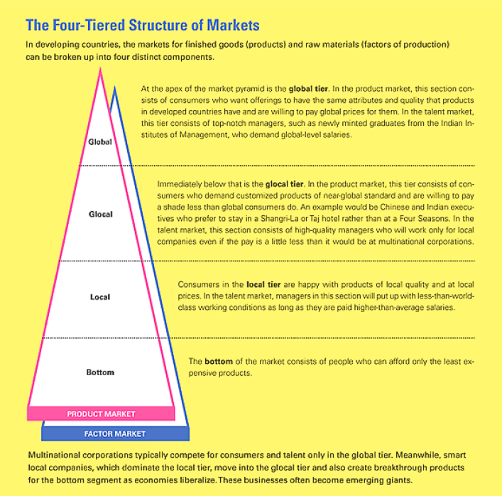[15]

# Companies’ successes depend on their ability to exploit their competitive advantages. Since emerging giants both circumvent institutional voids and tailor their strategies to local markets better than multinational companies do, they initially take on foreign competitors by capitalizing on their ability to navigate their home turf.

# They do that by using one of four strategies.

# **Exploit Understanding of Product Markets**

# Many emerging-market companies have become world-class businesses by capitalizing on their knowledge of local product markets.

1. **Build on Familiarity with Resource Markets**

Some emerging-market companies have gained competitive advantage by exploiting their knowledge about local factors of production—the markets for talent and capital—thereby serving customers both at home and abroad in a cost-effective manner.

1. **Treat Institutional Voids as Business Opportunities**

The third way to build emerging giants is for private sector businesses to fill institutional voids. Only governments can set up certain institutions, but companies can own and profitably operate many kinds of intermediaries in product and factor markets. Several emerging giants have learned to play the role of market institutions. Consider Old Mutual, an insurance company that realized that South Africa lacked mutual funds and other long-term investment products. Old Mutual responded by creating insurance policies for poor people that had the features of savings accounts. By marketing the policies to millions of South Africans, the company became a large financial services firm. When the South African economy integrated itself with the world market in the early 1990s, Old Mutual moved into other African countries, such as Botswana, Kenya, Malawi, Namibia, and Zimbabwe, and listed itself on the Johannesburg and London stock exchanges.

1. **The Importance of Execution and Governance**

Identifying the right growth strategy is critical for building a world-class business, but execution and governance determine whether companies in emerging markets can realize their potential. While that may be true about building great companies anywhere, our research suggests that excellent execution and good governance are particularly valuable in newly industrializing countries. Financial and talent resources in emerging markets are scarce, but companies that can execute well end up getting more out of them. And since resource providers cannot rely on the enforcement of contracts in emerging markets, good governance and organizational mechanisms that ensure that a company lives up to its commitments to investors, customers, employees, and business partners—allows an organization to acquire a reputation that is invaluable in its dealings with constituents. It can, for instance, access the best resources at the lowest cost. [16]

# business problem or opportunity area

According to the PWC Global Outlooks study, global retail and consumer goods companies are eyeing South Africa’s burgeoning middle class. The biggest news was Wal-Mart’s R16.5bn 2011 acquisition of 51% of Massmart, which operates local retail brands such as Game, Makro, Builders Warehouse and Cambridge Food. Despite stiff opposition from Unions and sections of Government, notably the Department of Economic Development, both of whom feared widespread layoffs, South Africa’s Competition Commission approved the deal. The American retailer was to initially focus on the South African market, but plans to use Massmart’s presence in 12 African countries as a stepping-stone into the continent. It is almost certainly not alone in such aspirations. Experts estimate that there are now around 50 million middle-class households across Africa, measured as those with incomes of at least US$20 000 – about the same as India. This can be easily seen through increasing investments in retail infrastructure, with many large Western-style shopping Centre’s opening up. Ghana opened its approximately R250m Accra Mall in 2009, its’ first. Kenya’s Nairobi already has a thriving retail scene. In December 2011, over R700m was spent in Lagos, Nigeria developing the City Mall. The Angolan capital, Luanda, has embarked on a multi-billion rand, 15-year redevelopment of its seafront, which will bring offices, hotels and retail outlets. South Africa’s retailers have been among the quickest to snap up such opportunities. The anchor tenants of many of these new malls are typically well-known names from the southern tip of Africa, such as Shoprite, Woolworths, Mr. Price, Truworths, Pick ‘n Pay and Game, along with food chains such as Spurs. Shoprite is among the most ambitious of these, but nearly all the major South African brands have plans to find new growth up north. For consumer goods companies, much of this is already old news. Giants such as Unilever, Nestlé and Coca-Cola have traded across Africa for decades, while SABMiller has used its strength across African markets to become a major global competitor and the world’s second-largest brewer. Other consumer goods companies and retailers are now adding Africa to their growth plans. For many, the most obvious starting point is South Africa. This, due to South Africa’s established infrastructure.

Shoprite Holdings maintained its leading position in retailing, thanks to fierce price competition and aggressive marketing campaigns. The presence of Wal-Mart / Massmart resulted in solid competition between retailers. The initiative of price discounting by Massmart led other retailers to answer with growing and aggressive promotional activities, and the increasing presence of private label.[17]

A study on the Wal-Mart acquisition of ASDA, a British retailer, highlights the potential positive and negative implications when a massive retailer such as Wal-Mart decides to enter into a new market. The study sought to understand the implications on local retailers in the British retail industry after a giant retailer such as Wal-Mart entered the market place. The study used an interesting company performance metric of shareholder value as it uses future discounted cash flows to generate it and strategic actions taken by both foreign and local retailers. It is understood that this will affect future cash flows and ultimately shareholder value. The factors expected to affect shareholder value are:[18]

1) The seriousness of the threat imposed by the entrant on the incumbent retailer

2) The incumbent retailer’s ability to withstand the threat of the new entrant

The seriousness of the threat is comprised of how much of an overlap there would be between the new entrant and existing retailers in terms of assortment, positioning and the country of entry. Whilst, the capacity to withstand the threat is dependent on financial resources (.i.e. Size, Profitability, Financial Leverage) and organizational capabilities. Depending on how each company fairs in each aspect, their ability to cope with a new entrant is affected and will ultimately affect the shareholder value. This study also highlights the fact that currently existing firms within the market have an option to take proactive measures against possible new entrants into their local markets.

It can be agreed that global retailers entering a developing economy or a retail industry that is still formalizing, will bring best practices from around the world, up skill the local staff, invest in the development of the industry, etc. However if local retailers are not prepared for the entrance of new competitors, this can result in the local retailers not being able to compete or not having great success in the industry. However a major stumbling block for most international retailers that are looking to expand into foreign markets is that they do not have knowledge or insight on the consumer versus the locally established retailer[19]. In most cases the international competitor suffers a few losses before the right decisions are made to accommodate the local consumers’ purchasing patterns. This is one of the main reasons why international retailers will look to the

South African retail industry, for possible acquisition targets that have pre-established footprints in Africa and have accumulated a wealth of knowledge about how best to do business in Africa. This saves both critical time and money.

Foreign investors are particularly interested in well-managed South African retailers that are able to deliver returns in a tough economic environment. South African retailers are seen as having strong management structures able to deliver returns despite a difficult operating environment. Foreigners are pleasantly surprised about business conditions and how good management is and how they eke out returns in a tough environment. Local retail stocks have returns on equity, a measure of profitability, ranging from 20% to 50%. Investors are not concerned that South African equity is expensive as long as management deliver earnings growth.[20]

The fast-growing economies of Africa present a compelling investment case. By 2030, the continent’s top 18 cities could have combined spending power of $1.3-trillion. An analysis of this trend cannot be completed without investigating the reasons why international competitors from developed countries would look to establish themselves as players in the retail industry of developing countries. Global companies are actively seeking to increase their footprint in lean countries such as SA, due to a number of economically advantageous factors such as low labour costs, world class banking services and excellent infrastructure. "The sophisticated business environment of South Africa provides a powerful strategic export and manufacturing platform for achieving global competitive advantage, cost reductions and new market access,” South Africa has been identified as being the most feasible entry point into the Southern Region of the African continent and is also perceived as being the ideal gateway into the African market as a whole.[21]

The 2014 Global Retail development index has also reported that Global retailers are aggressively expanding their operations into developing markets from South America to South East Asia to Southern Africa and have been buoyed by a more upbeat economy and growing retail environments.[22] Price Waterhouse Coopers (PWC), through their published retail outlook 2012-2016 reported that, leading the charge in this turnaround is South Africa, the continent’s most sophisticated economy. It is already the biggest retail market in sub-Saharan Africa, and the 20th largest in the world, with a wide array of shopping malls and retail developments, as well as a sizable food and non-food manufacturing sector. While average GDP growth rates are modest, per capita incomes are far higher than elsewhere on the continent.[23]

Furthermore, local consumers are highly aspirational and brand conscious, making for a thriving and competitive retail and consumer goods market, as a visit to any of the country’s many large shopping malls will attest. More international brands and retailers were taking up space in South Africa’s shopping centers as consumers bought into international brands and the local industry acquired world-class standards, Amanda Stops, the chief executive of the SA Council of Shopping Centers, commented to the Business report in August 2014.[24]

The PWC retail outlook report has however indicated that despite the headline Massmart acquisition, few retailers expect a rush of mergers and acquisitions. The Economic Intelligence Unit has reported that South Africa is indeed following in the footsteps of many other emerging markets by developing an increasingly large band of middle-class consumers and for retail and consumer goods companies in particular, these consumers are highly aspirational and have plenty of opportunities to deploy their disposable incomes, with local cities well stocked with modern malls. These cater to a local consumer culture that places a premium on high-end consumer goods, from fashion labels through to luxury car marque and therefore, despite the challenges, global retail and consumer goods companies are eyeing South Africa’s burgeoning middle class with the most notable entrant being Walmart’s R16.5bn 2011 acquisition of 51% of Massmart, which operates local retail brands such as Game, Makro, Builders Warehouse and Cambridge Food.[25]

Fin24 released an article stating that with European retail markets looking less attractive because of the financial crisis, the retail sector of lean countries are in the sights of foreign retailers who want to expand their turnover and improve sales. International players are also lured by SA's cheap (in global terms) property rentals. Stephan le Roux, retail director of Growthpoint Properties, one of SA's biggest mall owners, says SA offers relatively low overhead costs for foreign retailers, which translates into higher margins.

## SUPERMARKET & WHOLESALE CLUSTER

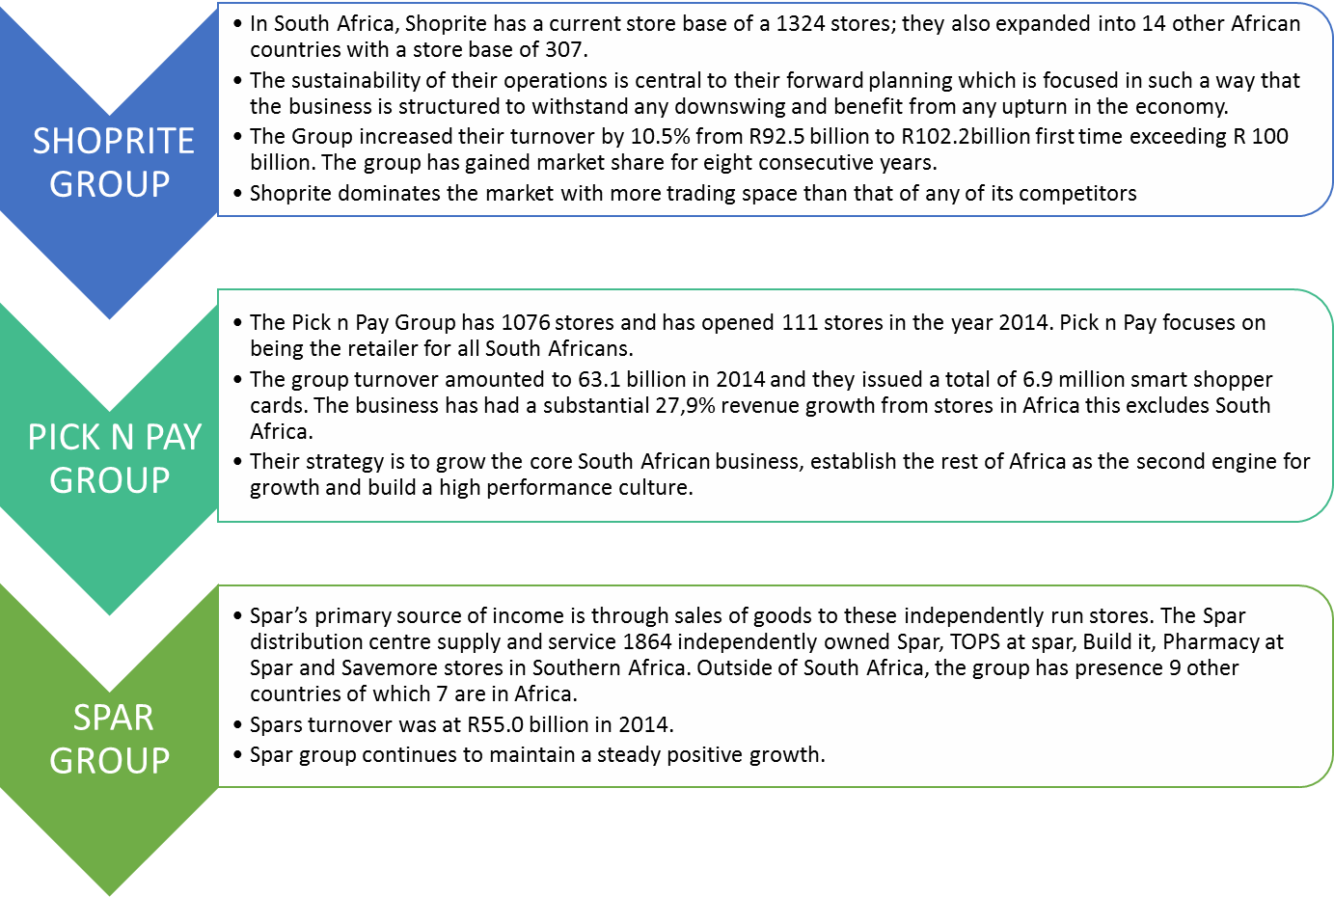[26]

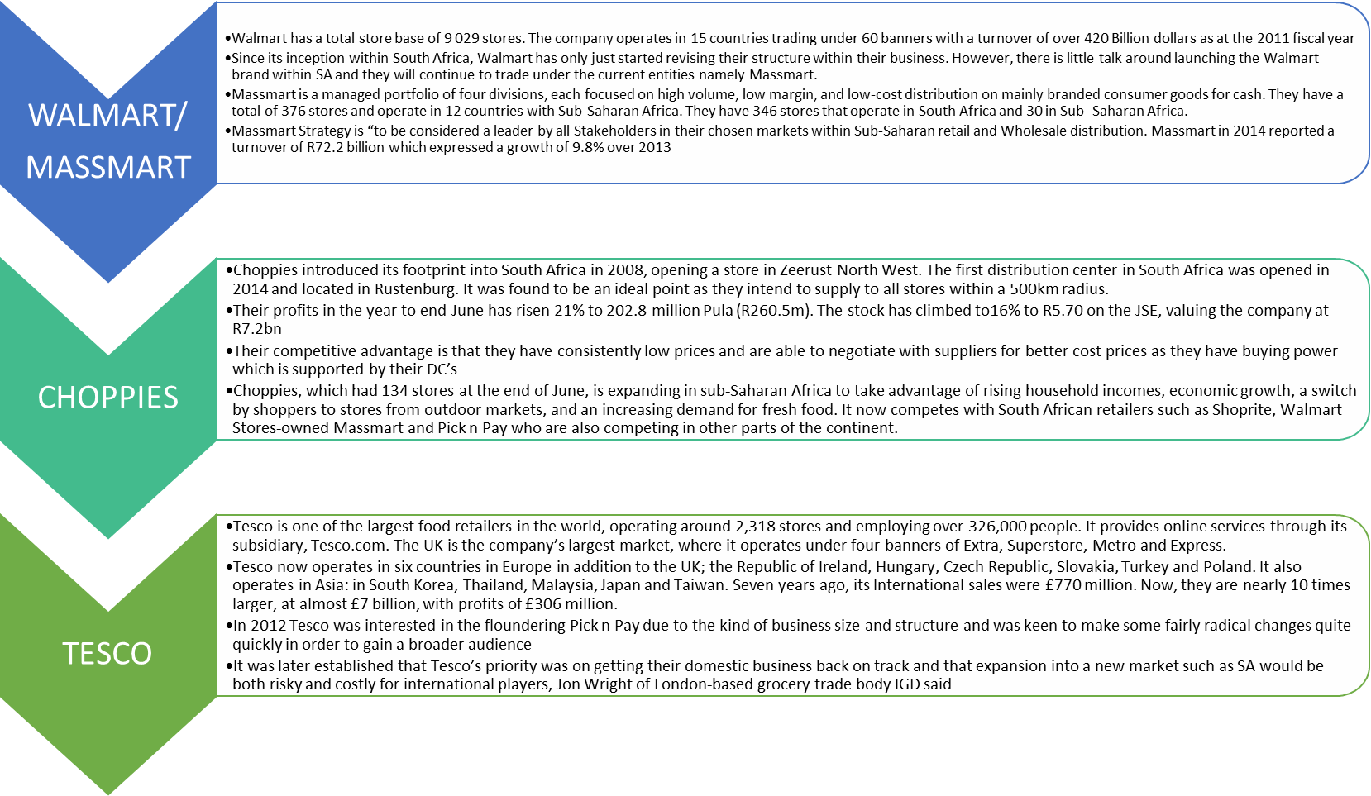[27]

#### Findings through our research process

Our research and interview process within the food & beverage cluster has resulted in the following responses.

**Primary growth strategy of local retailer in SA**

It is evident that the growth strategy and driver for most big food retailers is that of organic expansion and complementary business services. These include the development of pharmacies, liquor outlets, event ticketing services, travel, fuel and basic financial services.

### Growth into Africa

Considering that the local SA market is approaching relative maturity the opportunity represented by the oil-rich West African countries that previously lacked strong formal retail representation is important to these retailers in the next 10 years. This will be a significant driver of sales and profitability growth.

### Main barriers to further investment in the sector

In South Africa, the over regulation of consumer goods is creating unnecessary inefficiencies and costs. Examples are new foodstuffs labelling requirements, which make it difficult for even developed economies to export their products into the country. Furthermore, the Consumer Protection Act makes the South African consumer one of the most protected in the world.

In Africa, the bureaucracy of intra-African trade is a major challenge. Tedious trade agreements and administration-heavy import/export requirements make cross-border trade a lengthy and complicated process. The inefficiency of various customs agencies and government departments make product distribution lead times untenably drawn out and inefficient, which has a negative impact on product availability and costs.

South Africa is part of the global world and they cannot hide from their international competitors however, many of the big retailers are neither alarmed nor threatened by the thought of new entrants in the marketplace. At present, they cannot see any retailer wanting to enter SA based on the economic downturn, the results of the Walmart acquisition and the most significant factor of having world class local retailers to compete with. Another positive is that South Africa has always been an extremely competitive retail environment however, the local retailer is concerned about overtrading and over-storing. .

The entry of international players into this market have been long anticipated and the local retailer feels that they have adequately prepared themselves.

## CLOTHING & TEXTILE CLUSTER

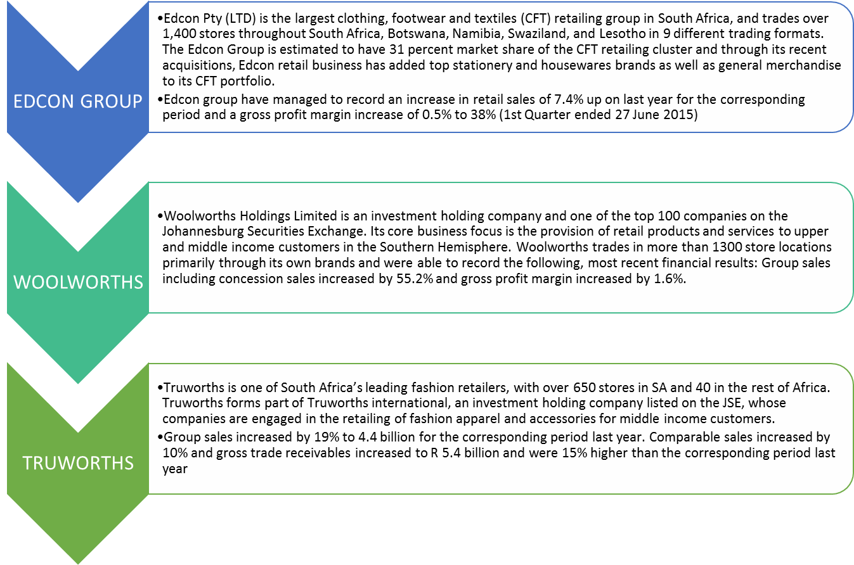

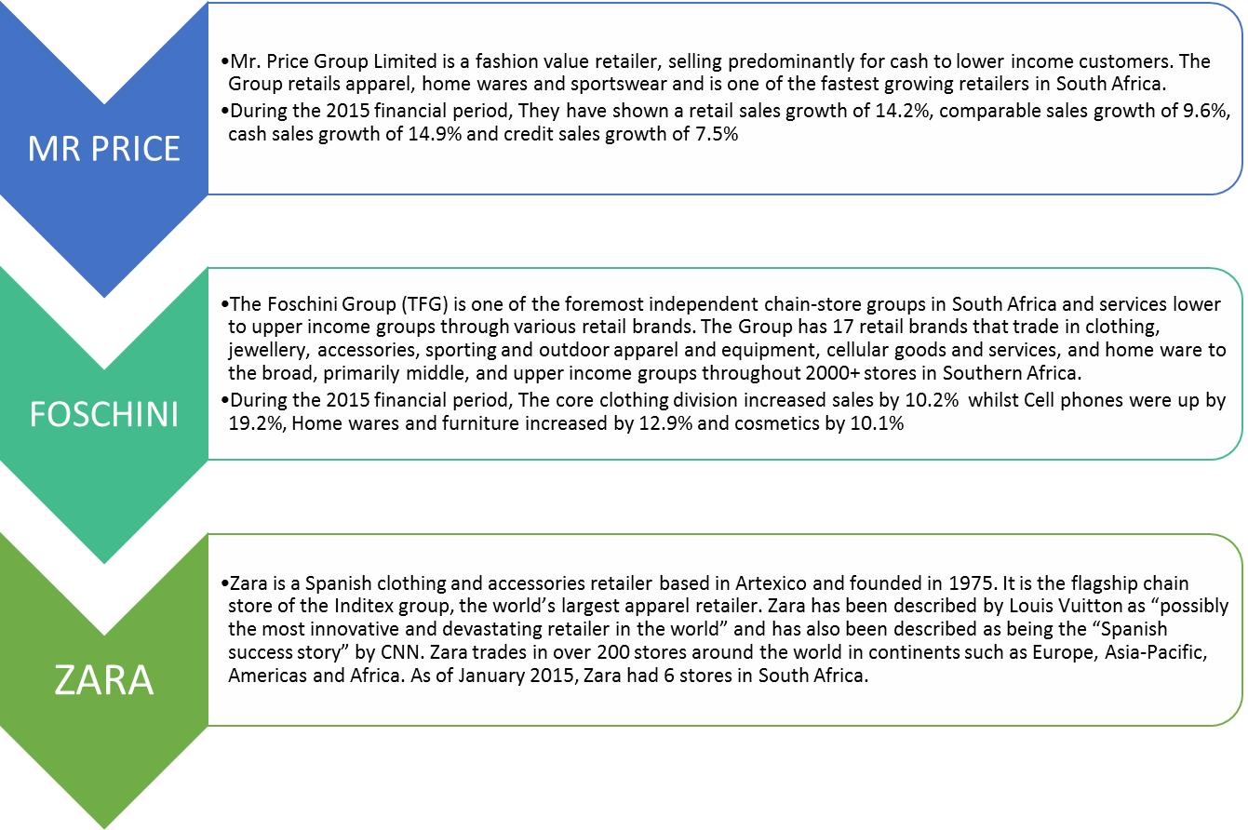

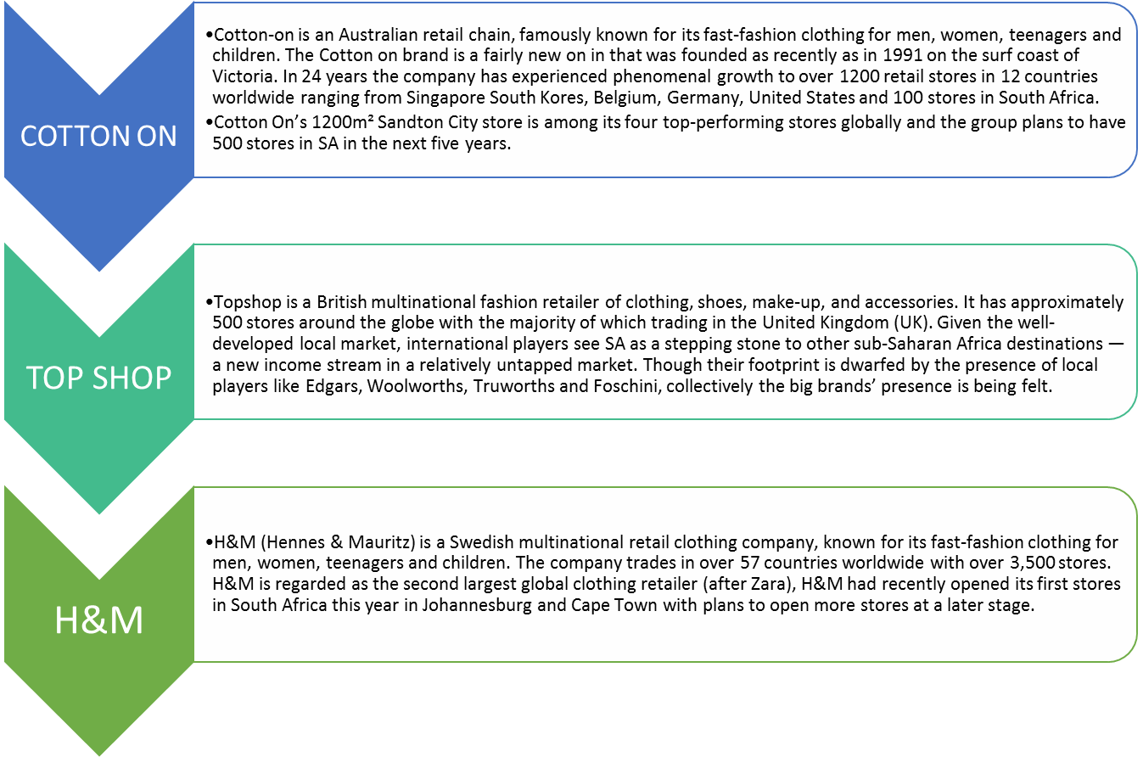

The international retailers are often mass marketed in terms of fashion and quality, yet when these businesses bring merchandise to South Africa; it tends to be quite expensive. They also do not have the credit offering that a number of retailers in South Africa are able to extend. According to Truworths CEO Michael Mark, the fashion retailer regards global competition in the same manner it does local competitors. "International retailers who open stores in South Africa do not necessarily understand trends better than we do and they face their own difficulties in trading in South Africa," he said. "While the group will never become complacent to the threat of local or international competition, we believe that if the right fashion is available in our stores, it will continue to attract customers, regardless of the level of competitor activity. “Local retailers are not resting on their laurels in the face of increased competition — the Foschini Group‚ Truworths and Edcon are streamlining sourcing and speed-to-market efficiency. Meanwhile, Woolworths will bring the Witchery and Mimco fashion brands to South Africa in March. Along with new brands in its arsenal, Woolworths’ enhanced procurement strategy and better relationships with its suppliers has allowed it to shorten lead times. The upmarket player, which wants to be a leading fashion retailer in the southern hemisphere, hopes to emulate the success of its other Australian labels, Country Road and Trenery.[28]

A research survey was recently conducted with a total of 600 respondents in an effort to gain some insight as to the levels of loyalty customers have to either South African retail companies or that of international brands, the results of which are documented in appendix C[29]

The results of the survey indicate that a large majority of customers are between the ages of 25 to 44 with an equal number of male and female consumers skewing slightly towards female. The average monthly household income is between R6 000 and R10 000 with 53% of the respondents indicating that they spend at the least R0 to R500’s worth of cash whilst a lesser yet significant amount of the respondents have indicated that store credit determines their spending. It is clear that the South African consumer prefers local retailers by a dazzling and unmistakably 93% of our survey respondents with nearly 60% of these respondents being influenced by family and friends.

The above results paint a very vivid picture of the mindset and behaviours of our SA consumer. They are traditional and loyal clothing spenders who find that the majority of their needs and expectations are being met by their local retailer.

The results of the survey indicate four key touch points that will ensure a competitive advantage for the SA clothing retailer.

Namely and in order of significance:

1. Price & Affordability
2. Quality
3. Range
4. Customer Experience

We also conducted a price comparison between a leading South African retailer against an International clothing retailer within South Africa. This exercise was aimed at determining the price competitiveness of both retailers.

Truworths Women [30]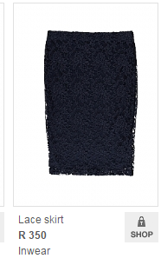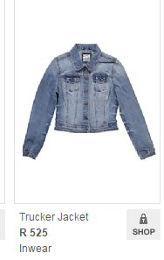

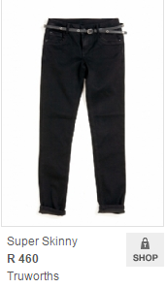

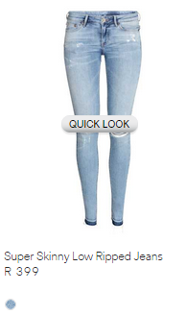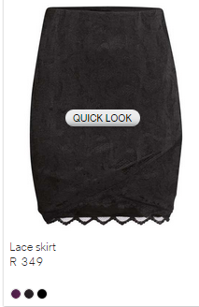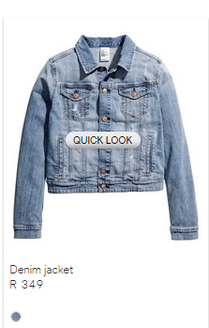H&M SA [31]

|  |  |  |  |
| --- | --- | --- | --- |
| **Store** | **Denim Jacket** | **Super Skinny Jeans** | **Lace Skirt** |
| Truworths | R 525.00 | R 460.00 | R 350.00 |
| H&M | R 349.00 | R 399.00 | R 349.00 |
| Price Difference % | 50% | 15% | 03% |

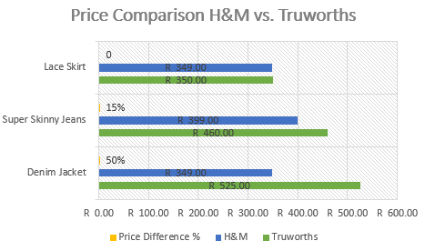

Our findings indicate that the top end SA retailer is overpriced by an average of 22% on a basket of clothing. The prices offered by their international counterparts are sharp and competitive and the price factor will eventually pose great challenge and pressure to the top end SA retailer such as Truworths, Woolworths & Foschini.

Our research has indicated that the international competitors are able to gain market share over the SA retailer through sharper pricing, fast fashion and through the gaining of critical mass within the SA retail landscape.

The challenge for these top end SA retailers will be their preparedness to reduce their selling prices despite fixed costs and overheads.

# OBJECTIVES & SCOPE OF PROJECT

The range of our perceptions, thoughts and actions for this investigation are focused on two of the seven retail clusters, namely:

• Retailers of food, beverages and tobacco in specialised stores;

• Retailers in textiles, clothing, footwear and leather goods;

As a research team we have therefore excluded the four remaining clusters, namely:

• Retailers in pharmaceutical and medical goods, cosmetics and toiletries;

• Retailers in household furniture, appliances and equipment;

• Retailers in hardware, paint and glass; and

• All other retailers.

A number of factors have influenced our thinking and subsequent decision to limit the scope of our research investigation to the above mentioned clusters. One of these reasons is based on the number of internationally recognised retailers that have already begun trading in South Africa. Most of these globally recognized retailer’s trade in one or more of the two clusters we have identified as being an integral part of the research thereby offering a rich framework of research to work from.

Another important reason is one of a personal nature. As a group, the majority of our members form part of the two identified clusters through employment. This type of research is therefore an opportunity to not only learn, but to also practically apply the learnings and possible responses in the companies we work for.

Research of this nature suggests that international competitors that have focused on expanding into Africa originate from a number of different countries and continents. The focus of this research however will be limited to the study of retail companies that originate from advanced economies, mainly European, American and Eastern countries.

A number of assumptions need to be explored when conducting research of this nature. For starters, in looking at the recent economic developments which saw the emerging economies overtake the advanced economies in terms of contribution to world economic output, in late 2012, this interesting dynamic has ensured that that over the last five years the world’s fastest growing region is represented by the economies that make up Sub-Saharan Africa and south-east Asia.

These changes by their mere nature cause the assumption that not only will we witness structural changes in South Africa, but that South Africa’s economic prospects and competitive strength could be materially improved by establishing economic relationships with these dynamic markets whilst protecting and nurturing established partnerships.

This dynamic and projected outcome also leads to the assumption that South Africa will continue to be a desirable location for international retailers to trade in and expand their business for the foreseeable future. It is also assumed that the sample audience will provide honest and reliable responses/information when probed for this.

There are a number of unavoidable constraints that need to be successfully dealt with in conducting this research project of this nature such as restrictive access to information from the international retailers in their efforts to safeguard their strategic plans. Access to some or all our sample audience might also prove to be a constraint due to conflicting meeting schedules.

Time and budgetary constraints are also likely to prove an issue along with any legal or ethical constraints as a result of confidentiality issues particularly amongst local retailers (sharing of information).

As a team we have identified a number of research goals and objectives which we would like to achieve. First and foremost, we would like to make use of the best and most suitable methodology in producing a credible and informative research assignment.

We would also like to produce a high quality assignment which is not only used for academic purposes, but one that comprises of a number of practical solutions that can be implemented in the retail sector. Our research team would like to be meticulous and thorough during the research phase so as to produce a comprehensive view of the subject matter.

We would also like this research project to become the benchmark for all research of a similar nature going forward. It is also our intent to leverage our learnings so as to positively influence the whole sale and retail industry and that of our respective companies.

Our research team would also like to establish sustainable connections within the retail industry for past and future students to be able to call on for research purposes. We would also like to represent not only our companies, but that of our academic institutions to the best of our abilities in all our interactions with the various stakeholders.

These objectives will be met by focusing on specific cluster of questions that will be directed at the sample audience we have identified as being crucial to this type of research.

# Research Methodology

|  |  |  |  |
| --- | --- | --- | --- |
| **Research Method** | **Audience** | **Objectives** | **Who is responsible** |
| Focus groups, surveys, documents & observation | **Consumer/Customer** | To determine what drives the SA consumer purchasing decisions | Herc |
| Documents, observation & Interviews | **Companies** | To understand current strategy and their future strategy in response to international competition | Olivia |
| Documents & interviews | **Support companies** | To establish the nature of the role supporting companies will play in response to international competition | Denzil |
| Documents & interviews | **External authorities** | To gather data to assist in differentiating between local and international activities | Bilal |
| Documents & interviews | **External companies** | To determine supply chain and manufacturing efficiencies of international retailers in SA so as to identify areas of opportunity for the local retailer | Trevor |
| Documents & interviews | **Government** | To understand the regulatory demands/policies on retailers by the SA government | Philly |

### Key Stakeholders identified for research purposes:

• Customers

Viz. Family & friends, SANCU, Panel of consumers

• Companies

Viz. Syndicate companies and other retail organisations within our scope

• Support Companies

Viz. Financial, Legal and advisory, Service providers, credit bureau

• External Companies

Viz. Suppliers, Manufacturers and Supply chain specialists

• Government

Viz. DTI, WRSETA, Empowerdex, Nedlec, SARS

• External Authorities

Viz. Nielsens, Aztec, SACCI, FASA, CGSA, BLSA, SARC and SACSL

## RESEARCH QUESTIONS

### Government & Other Authority Bodies:

### 1. What role do you play in assisting global competitors in entering local markets?

### 2. What supporting role do you play with local retailers and how do you envision this changing based on the global entrants within SA?

### 3. What are the entry requirements for foreign entrants within SA?

### 4. How are local retailers protected against global entrants within SA?

### 5. What is governments’ vision for SA retail in the next five years?

### 6. How are global retailers impacted by BBBEE?

### SA Retail Companies:

### 1. What is your go to market strategy?

### 2. What risks does your organization face against global competitors?

### 3. What are your plans to retain your current customer base as well as grow and expand?

### 4. Who have you identified both locally and internationally as your competitors?

### 5. What is your strategy in response to these global entrants?

### 6. What are the differentiating consumer trends both locally and internationally?

### Consumers:

### 1. What attracts you to a certain retail store?

### 2. What are your needs as a customer?

### 3. Where do you currently shop?

### 4. Why do you shop at that particular store?

### 5. What impact does pricing have on your purchasing decisions?

### 6. Who do you shop with?

### 7. How does local retail appeal to consumer purchasing behaviour?

Interview List

|  |  |  |  |  |  |
| --- | --- | --- | --- | --- | --- |
| NAME | COMPANY/ORG | ROLE | CONTACT | | EMAIL |
| Nazim Cassim | MDD - Dion Wired | Director | 031-5345897 | [neathas@mdd.co.za](mailto:anthiao@mdd.co.za) | |
|  |  |  |  |  | |
| John Wilkonson | PWC | Retail and Consumer Leader | 27215292086 | [john.wilkinson@za.pwc.com](mailto:john.wilkinson@za.pwc.com) | |
|  |  |  |  |  | |
| Diederik Fouche | PWC | Consumer and Industrial Products Leader | 27117974291 | [diederik.fouche@za.pwc.com](mailto:diederik.fouche@za.pwc.com) | |
|  |  |  |  |  | |
| Shenaaz Peer | PWC | Business Development Manager | 27117974185 | [shenaaz.peer@za.pwc.com](mailto:shenaaz.peer@za.pwc.com) | |
|  |  |  |  |  | |
| Ismail Moolla | Delloite |  | 27827448255 |  | |
|  |  |  |  |  | |
| Riyaad Sumar |  |  |  |  | |
|  |  |  |  |  | |
| Mohomed Wadee | KPMG |  |  |  | |
|  |  |  |  |  | |
| Amina Nagdee | KPMG |  |  |  | |
|  |  |  |  |  | |
| Mohomed Cajee | EY |  | 27833146997 |  | |
|  |  |  |  |  | |
| Jameel Nagdee | Investec | Specialised Finance | 27836019930 | Jameel.Nagdee@investec.co.za | |
|  |  |  |  |  | |
| Anne Croty | Sunday Times | Financial Journolist |  | acrotty@worldonline.co.za | |
|  |  |  |  |  | |
| Syd Vianello | Nedbank Capital | Retail Analyst |  |  | |
|  |  |  |  |  | |
| Michelle Delport | Innervation Group | Key Account Manager |  |  | |
|  |  |  |  |  | |
| Kathryn Robinson | Investec | Analyst |  | [Kathryn.Robinson@investec.co.za](mailto:Kathryn.Robinson@investec.co.za) | |
|  |  |  |  |  | |
| Daryll Jackson | KPMG | Clients and Sectors | 27116476895 |  | |
|  |  |  |  |  | |
| Rene | SA Council of shopping centres | Secretary to CEO | 27848476887 | rene@sacsc.org.za | |
|  |  |  |  |  | |
| Amanda Stops | SA Council of shopping centres | CEO |  | amanda@sacsc.org.za | |
|  |  |  |  |  | |
| Wilna Vanzyl | National Treasury |  |  | [wilna.vanzyl@treasury.gov.za](mailto:wilna.vanzyl@treasury.gov.za) | |
|  |  |  |  |  | |
| Dorthy | JCCI | Marketing Manager |  |  | |
|  |  |  |  |  | |
| Patricia Pillay | SA Retail Council |  |  | [aviwem@cgcsa.co.za](mailto:aviwem@cgcsa.co.za) | |
|  |  |  |  |  | |
| Freda | NEDLAC |  |  | [nthabiseng@nedlac.org.za](mailto:nthabiseng@nedlac.org.za) | |
|  |  |  |  |  | |
| Mohammed Nala | Nedbank Capital | Analyst |  | [mohammedn@nedbankcapital.co.za](mailto:mohammedn@nedbankcapital.co.za) | |
|  |  |  |  |  | |
| Kirsty | Investec | Retail Equity Analyst |  |  | |
|  |  |  |  |  | |
|  | Investec | Food & Beverage Analyst |  |  | |
|  |  |  |  |  | |
| Jacques Beukes | Redefine Properties | Property Manager | +27 12 323 9928 | [jacquesb@redefine.co.za](mailto:jacquesb@redefine.co.za) | |
|  |  |  |  |  | |
| Yusuf Enver | Choppies Landlord Polokwane | Landlord | 27828446000 |  | |
|  |  |  |  |  | |
| Sonke Moolman | Operations | Moolman Properties | **+27 (0)82 738 3733** |  | |
|  |  |  |  |  | |
| Abdullah Varachia | RMB - GIBS |  | 27827677700 |  | |

Key Lessons from Ghana, India and China

A number of key lessons have been derived from our recent trips to the above mentioned countries which could prove useful to our local retailers.

**GHANA**

Most South African retailers in Ghana are willing to pay the price of being the first mover into the formal retail environment. It was made very clear to us that deep pockets are required in order to establish a retail operation in Ghana, this is due to the time it requires for the market to accept you and your products as well as for South African retailers to gain clear insights and understanding into the local consumer. At present, not much market empirical data exists and as such retailers are learning as they conduct business.

This contrasts greatly with foreign retailers entering South Africa as these foreign retailers are landing on shores which are hungry for foreign retailer products, with a consumer that has been well researched and documented. The bulk of foreign retailers coming to South Africa are using the country as an entry point into the rest of Africa and this contrasts with the South African retailers who are already trading in West Africa namely, Ghana. The Ghanaian retail sector is still pre-dominantly informal and second hand goods are bought and sold throughout the various markets. Formal retail exists within large shopping centers which also happen to be built by South African organizations.

South African retailers in Ghana make up the largest contingent of foreign retailers, and in some shopping centers one could easily make the mistake of thinking that you are in a South African shopping environment. This highlights the lead that South African retailers have in Africa over the foreign retailers.

During the course of our travels to China and India, it became increasingly apparent that the local retailers see a greater need to focus on their local retail market as opposed to expanding their operations cross continents and seas. The population size and density in the respective countries is extensive and continuously growing, which provides innumerous opportunities for the local retailers to reap more returns within the confines of their respective countries and can almost exclusively focus on the market within their own locations.

Interviews with various CEOs that were met along our journey clearly indicated that their vision was to focus on cementing their positions within their local markets and to gain more exposure and penetration, specifically with consumers that are situated far from the central business districts

**CHINA**

The Chinese retail environment is dominated by Asian retailers, not necessarily Chinese. The large population and single child policy means families have more disposable income and are searching for that next retail offering. Chinese are considered to be savers, however it is hard to comprehend given the large scale proliferation of retailers throughout Beijing. Retailers occupy end to end on every street, with competitors located alongside each other. Foreign retailers have entered the Chinese retail environment, with the bulk choosing to be located in shopping centers or high streets.

We did not come across any South African retailers in Beijing and whilst China presents a large consumer market, their purchasing behavior is complex and rather confusing and needs to be well understood, as experienced by the retail giant Walmart who have yet to fully succeed in this country. The experience of Walmart in China contrasts greatly with their successes in South Africa and highlights the fact that the SA retail landscape is a ready market and far more easy to understand.

**INDIA**

Many India’s in one India; this mantra was banded about by every retailer we visited. Catering for the whims and needs of a diverse consumer market is of utmost importance in India. Success is based on acknowledging and understanding the various consumers. India has recently opened its doors to foreign retailers and they are pouring into the country, much like South Africa, however the “size of the prize” is much larger in India.

The Indian populous has gone through a boom in telecoms and as a result a large portion of the population have access to a cell phone and also ultimately the internet. This has caused a shift in focus from traditional forms of marketing and retailing to mobile marketing and e-tailing. This phenomenon is allowing retailers to access parts of the market and consumers that were previously impossible to access. This presents another avenue to gain market insights on consumer shopping patterns and preferences which retailers can use to more effectively target consumers and grow their consumer base. South African retailers have tried and failed in India, however the market and consumer seems to be undergoing major behavioural shifts, which could bode well for South African retailers considering entering or re-entering India.

Recent trends in South Africa have led to all of the identified main players looking to expand their operations both in Africa, and in various countries around the world and the decision to expand operations globally must certainly be accompanied with the right infrastructure and support teams to ensure effectiveness to such strategic plans and brand promise.

The resulting lesson through our interactions with the retail giants of China and India have been that South African retailers who have taken the leap to expand internationally should only do so as a secondary business strategy without losing sight of their homegrown market share and competitive advantage over the international retailers who have set their sights on SA.

# Discussion of Results

Some of the major findings thus far are: [32]

* Total retail sales will continue to expand steadily, driven in particular by the continued emergence of a black middle class.
* Unemployment will remain the country’s largest drag on growth, entrenching high rates of income inequality. This has been further exacerbated since the 2009 downturn and will remain a key policy challenge, not least amidst sharp income inequality.
* Although overall growth will be moderate, sales growth will be strong at both the low-end and high-end, reflecting South Africa’s income spread.
* Although South Africa’s retail market has bounced back from recession, growth prospects remain fragile, with considerable downside risks.
* The country may have joined the league of the ‘BRICS’ in name, but growth rates here remain highly uncertain. GDP is expected to expand by 2.8% in real terms in 2012, down from 3.1% last year. This is far below the rate required to make a significant impact on unemployment rates, and more on a par with far more mature economies. In part this is shaped by the weak global economy and the Eurozone crisis. However, local issues constrain growth too, such as uncertainty over policies related to labour flexibility, along with a growing legislative burden, such as more onerous product labelling requirements and other requirements introduced in the newly-promulgated Consumer Protection Act. Furthermore, the competitiveness of the local consumer goods manufacturing sector is being challenged by lower cost international rivals.
* For local retailers and consumer goods firms, the rest of Africa is widely viewed as an opportunity for expansion.
* Despite the headline Massmart acquisition, few retailers expect a rush of mergers and acquisitions (M&A). At this stage of our research, it only refers to Walmart.

The South African retail scene is dominated by a small number of major retail and consumer goods companies, many of which could make appealing takeover targets.

Nevertheless, given the challenges of Wal-Mart’s acquisition, which attracted close scrutiny from the Competition Commission, along with strong local competition, few experts are forecasting a boom in M&A from foreign entrants. In part, this is because few major international food retailers appear to be moving quickly to enter the African market, while fashion brands and other retailers appear likely to expand organically, rather than via acquisition. However, given the limited availability of free retail space, such growth will necessarily happen gradually.

* Operational efficiency will be a core focus for retailers in the medium term.

The PWC outlook report aptly states that the past decade has seen a remarkable turnaround in the fortunes of the African market, which has been host to many of the world’s fastest growing markets. This has piqued the interest of the world’s retailers and consumer goods companies, as they search for new growth. But on the continent, there remains a significant gulf between South Africa’s highly developed and competitive retail market, and far less developed economies north of its borders. This has made South Africa an inevitable destination of interest for foreign rivals.

In turn, this is forcing local retailers to sharpen their performance, although many of them are rightly confident of their ability to stand up to the test. At a macro level, though, the country has little to be complacent about. Our economy faces significant downside risks to its future growth rate. This is partly due to its close links to the global economy, but also from its local policies. Policymakers have so far had few answers to its persistently

high unemployment rate, which is the single largest drag on potential consumer demand. Due to this, the maturity of the local market, and growth elsewhere in Africa, international players will increasingly compete with South Africa’s retailers for a stake in countries such as Nigeria, Kenya and Ghana. A new scramble for Africa is already underway. South Africa’s players will need to work hard to maintain their position in the future.[33]

# POSSIBLE RESPONSES & recommendations

# **Exploit Understanding of Product Markets**

# Many emerging-market companies have become world-class businesses by capitalizing on their knowledge of local product markets.

* **Build on Familiarity with Resource Markets**

Some emerging-market companies have gained competitive advantage by exploiting their knowledge about local factors of production—the markets for talent and capital—thereby serving customers both at home and abroad in a cost-effective manner.

* **Treat Institutional Voids as Business Opportunities**

The third way to build emerging giants is for private sector businesses to fill institutional voids. Only governments can set up certain institutions, but companies can own and profitably operate many kinds of intermediaries in product and factor markets.

* **Realize the Importance of Execution and Governance**

Execution and governance determine whether companies in emerging markets can realize their potential.

* Long-term success will depend on a continued focus on the consumer, **efficient supply chains and a low cost** of doing business. This will be particularly important for those companies looking to expand their footprint in Africa.
* Companies that **differentiate** their products or formats and provide a compelling reason for customers to buy from them will continue to survive. Those that don’t will face an onslaught from competitors.
* The ability of companies to **identify, react to and take advantage** of changing consumer behavior will determine their level of success.
* In difficult times like these, companies need to **critically re-examine** their cost structures, operational effectiveness and efficiency.
* **Localize before you globalize**. The reluctance of some of the Indian retail companies to expand their operations beyond the shores of India was attributable to the notion of the Indian market being extremely vast and complex, one which was not fully understood by Indian retailers. This has led to the idea that it is best to focus on Indian retailing rather than that of retailing in a foreign country.
* **Create new categories.** The idea behind creating new categories is that one should look to proactively shape consumer trends and behavior by creating new innovative categories. Creating new categories offers the local retail companies alternative areas of growth to that of their main revenue stream against the backdrop of a weakening economy. Examples of this line of thinking include: Truworths International Kids Emporium stores (LTD Kids; Naartjie Kids and Earth Child)
* Consider **alternate product sourcing** to minimize the risk of parity with competitors.
* **Customer service and experience** is deemed to be a fundamental hurdle in South African retail as identified through our survey. The recommendation is therefore to construct an online platform to engage store staff and educate people on key customer service traits relevant to each sector. Customer service needs to be taught as a skill in the retail sector such that certified people educated by the W&RSETA are seen as skilled and knowledgeable in the marketplace
* **Encourage the development of the local supplier base** for new South African suppliers to produce products that can compete with international brands .i.e. Pampers, Colgate, Weber, etc. Building this supplier base and strengthening the relationship will add additional barriers to entry and allow the retailers to compete more effectively on price and establish South African brands as seen with Tesco and its **house brands** contributing more than 50% towards its turnover.
* Local retailers should ring fence their core business and **expand and establish much quicker into Africa**. This would allow them time to build their brand equity well before the International retailers gain momentum.
* In order for local retailers to respond to the many challenges faced, retailers must proactively balance between topline performance, profitability and customer excellence. [34]

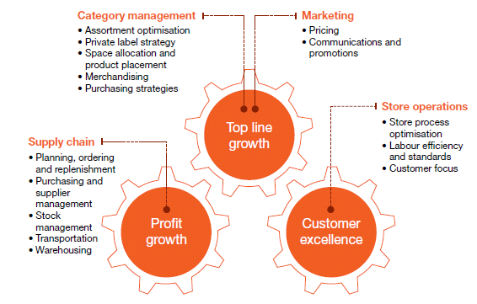

## Implementation Plan

1. The W&R Seta could serve as a repository of their knowledge and understanding of local product market base which could be shared with local businesses, thus creating a pool of best practice from and for local businesses. This knowledge base could also be used by small and medium enterprises to further develop the local industry, it would serve as a best practice guide for local entrepreneurs.

Start a pilot program for a consumer insights group that targets specifically the needs of a region and highlighting what are the requirements of the consumers and disseminating that information to the retailers for product development. Findings from this surveys could result in smaller pack detergents , consumers could also want toilet cleaners or bleach in that smaller quantity and thereby benefit the retailer in accessing a new customer group and in this case, the rural market.

1. Further entrench the implementation of best practice in the area of governance, South Africa has well developed governance standards, e.g. King 3

Assist growing retailers to implement these governance standards by creating scalable models for companies in different stages of growth.

1. Productivity SA – a government initiative to improve company productivity currently exists, this can be extended to assist retailers in improving overall organization competitiveness through productivity improvements. The expansion of the scope of Productivity SA will result in improvements and organizational gains currently not available to local retailers.
2. A DTI (department of trade and industry) desk which can assist by providing country specific solutions for companies expanding into the rest of Africa. Retailers who have ventured into the rest of Africa would have learnt many lessons along the way, these lessons need to be shared with other retailers, a viable model needs to be created for this information sharing.
3. Create an online platform to facilitate tutorials and learnings from the retail sector

Set up the platform for cluster specific retailers that work closely with the SETA and share and to view content with staff in order to improve their knowledge of the current market landscape.

Floors staff should be nominated to share experiences and lessons they have learnt about how to improve customer service

By using the online platform to do so and via nominations, creates a cycle of reflection for the staff and gives new perspective to staff from other retailers

1. Tiger Brands have employees that are based within the retail stores. These employees merchandise the Tiger Brands product on shelf and also influence the system ordering process to ensure that the correct and adequate quantities are ordered from the DC’s. Retailers should get these supplier companies to evolve with technology which would enable the employees to be more efficient at their stores. An example of technology and capabilities below that is used by Tiger Brands employees at these retail outlets.



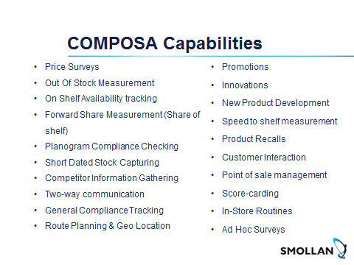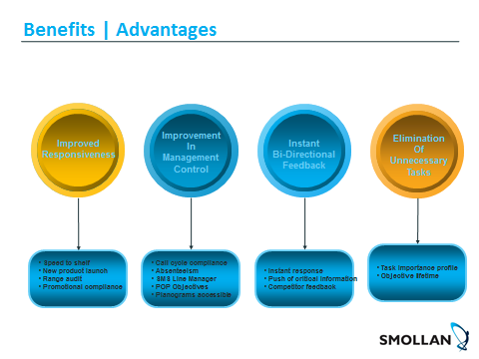

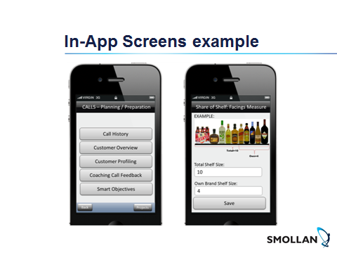

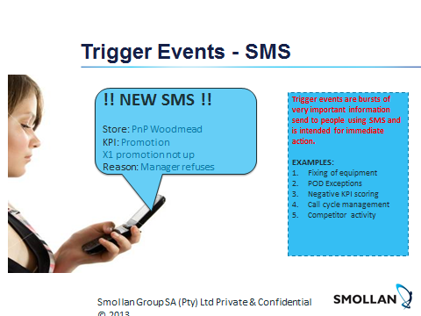

## Benefits to Tiger Brands for investing on employees based at the retail stores.

|  |  |  |  |
| --- | --- | --- | --- |
| **Capability** | **Phase** | **Impact** | **Benefit** |
| Store audits  Shelf Health , Promo, STS, OSA, Forward Share, Price Survey | 1 | Improved OSA  Increased space ( Drives)  Ranging Drives/Adhoc Activity | Sales R50 Million  Sales R5 Million  Sales 10 Million |
| Drives and measurement | 1 | Sales Mind-set | Adhoc Activity – R10 Million |
| Perfect Outlet | 1 | Sales Mind-set / Competitive Environment | Execs to determine |
| Franchise ordering systems  Digital Trade presenters  Blue Prints , Planograms | 2 | Ranging improvements  Adhoc orders  Ranging drives | 10 Million est.  1.03 Million |
| POS Management  Static price files and deals | 3 | Improved promotional POS compliance and usage | R 1 Million saving – BTL investment ( wastage) right stores , right periods |
| Paperless Environment  Ops books | 3 | Improved 2 way communication to all levels | R600K Benefit |
| E.g. Video based training  Market share | 4 | Product knowledge , Speed of training | R250K Est - Re investment to move to E. Learning Platforms |

Cost for introducing technology within the retailer base.

|  |  |  |  |  |  |  |  |
| --- | --- | --- | --- | --- | --- | --- | --- |
| **COSTS** | | | **COST SPLIT BY DIVISION** | | | | |
|  | **Once Off** | **Ongoing** | **S&T** | **Beverages** | **Grains** | **Culinary** | **HPCB** |
| **% Split** |  |  | 13% | 8% | 39% | 26% | 14% |
| **Once Off** | R502 |  | 65K | 41K | 195K | 131K | 70K |
| **By Month** |  | R887k | 115K | 71K | 345K | 231K | 124K |
| **Per Annum** |  | R10.44m | R1,38m | R852k | R4,15m | R2,76m | R1,5m |

The courses suggested below should be mandatory for all employees

|  |  |  |
| --- | --- | --- |
| **Orientation Courses** | | |
| **Courses** | **Duration** | **Merchandiser** |
| Group Orientation & My Customer 1 | 1Day |  |
| Merchandiser techniques & standards - Retail | 1 Day |  |
| Customer & Client Satisfaction | 1 Day |  |
|  |  |  |
| **Courses** | **Duration** | **Field Marketer** |
| Group Orientation & My Customer 1 | 1 Day |  |
| Merchandiser techniques & standards - Retail | 1 Day |
| Field Marketing Procedures and Documentation Retail | 1 Day |
| Customer & Client Satisfaction | 1 Day |
| Basic Team Leading Skills | 2 Day |
| Winning at the Point of purchase | 2 Day |
|  |  |
| **Courses** | **Duration** | **Mangers** |
| Customer & Client Satisfaction | 1 Day |  |
| Basic Team Leading Skills | 2 Day |  |
| Winning at the Point of purchase | 2 Day |  |
| Managing store procedures | 2 Day |  |
| Sales Management | 2 Day |  |
| Close a deal with a customer | 1 Day |  |
| Management Group Orientation | 1 Day |  |

# References

1. Ben-Shabat, H. Moriaty, M. Rhim, H. Salman, F. (2014). The 2014 Global Retail Development Index: Full Steam ahead for Global Retailers
2. Gauteng Province Treasury QB1 The retail industry on the rise – Economic Analysis Unit of SRM
3. PWC, South African retail and consumer products outlook 2012-2016
4. PWC, South African retail and consumer products outlook 2012-2016
5. PWC, South African retail and consumer products outlook 2012-2016
6. Tenase, G. 2013. The Retail growth strategies on the international market and the global development opportunities for retailers.
7. (Bianchi, C. C., & Reyes, C. (2005). Defensive Strategies of Local Companies against Foreign Multinationals Evidence from Chilean Retailers. Latin American Business Review, 6(2), 67. doi:10.1300/J140v06n02•04
8. The World Bank trade competitiveness toolkit - World Bank Publications – 2014
9. South Africa Economic Update (2014);
10. Dagmar Recklies - Porter’s Diamond – Determining Factors of National Advantage - 2011
11. http://www.productivitysa.co.za/index.php/about-us/about-productivity-sa
12. http://www.brandsouthafrica.com/projects/wef
13. Emerging Giants: Building World-Class Companies in Developing Countries by Tarun Khanna and Krishna G. Palepu
14. Emerging Giants: Building World-Class Companies in Developing Countries by Tarun Khanna and Krishna G. Palepu
15. Emerging Giants: Building World-Class Companies in Developing Countries by Tarun Khanna and Krishna G. Palepu
16. Emerging Giants: Building World-Class Companies in Developing Countries by Tarun Khanna and Krishna G. Palepu
17. Emerging Giants: Building World-Class Companies in Developing Countries by Tarun Khanna and Krishna G. Palepu
18. PWC, South African retail and consumer products outlook 2012-2016
19. Gielens, Van Der Gucht, Steenkamp & Dekimpe (2008),
20. Kumar, N. (2015). Retailers Struggling To Develop Competencies to Succeed Globally. Business Today, 24(3), 114.
21. Bizcommunity.com article, Gillian Jones 7 April 2015
22. South Africa.com, Global retailing
23. Global Retail development index 2014
24. PWC, Global; retail outlook, 2012-2016
25. Business Report, August 2014
26. PWC, Global; retail outlook, 2012-2016
27. Indeed Strategy, 2011
28. Massmart Group Annual Integrated Report, 2014
29. Kantar retail, Walmart’s approach for growth today, Rogers, AR November 2012
30. Shoprite Group Annual Integrated Report, 2014
31. Choppies integrated report 2015
32. Janice Kew, October 16 2015, 06:34 Business weekly / Retail & Consumer
33. www.ivoryresearch.coms trategicmanagementoftescosupermarketpestleanalysisporter5forcesana
34. www.ivoryresearch.coms trategicmanagementoftescosupermarketpestleanalysisporter5forcesana
35. Business Day Live http://www.bdlive.co.za/companies/2012/08/13/tesco-eyeing-pick-n-pay-walmart-style
36. Business Day Live http://www.bdlive.co.za/companies/2012/08/13/tesco-eyeing-pick-n-pay-walmart-style
37. http://www.edcon.co.za/about-retail.php
38. http://www.woolworthsholdings.co.za/corporate/profile-overview.asp
39. http://www.truworths.co.za/investors/about-us
40. http://www.mrpricegroup.com/CorporateProfile/Aboutus.aspx
41. http://www.fastmoving.co.za/retailers/the-foschini-group-4
42. http://www.zara.com
43. http://www.financialmail.co.za/coverstory/2014/07/10/global-retailers-challenge-in-the-making
44. http://cottonon.com/AU
45. http://www.thelocal.se/20130829/49936
46. http://www.financialmail.co.za/coverstory/2014/07/10/global-retailers-challenge-in-the-making
47. http://www.financialmail.co.za/coverstory/2014/07/10/global-retailers-challenge-in-the-making
48. http://www.financialmail.co.za/economy/2012/10/03/brand-new-landscape
49. http://www.bdlive.co.za/business/retail/2014/01/31/us-fashion-brand-forever-21-to-open-first-store-in-africa
50. https://www.surveymonkey.com/r/Consumer_Insights - Team Rockets
51. https://www.truworths.co.za/type/women - as at 18/11/2015
52. http://www.hm.com/za/products/ladies - as at 18/11/2015
53. South African retail and consumer products outlook 2012-2016
54. South African retail and consumer products outlook 2012-2016
55. South African retail and consumer outlook 2012- 2016

1. Ben-Shabat, H. Moriaty, M. Rhim, H. Salman, F. (2014). The 2014 Global Retail Development Index: Full Steam ahead for Global Retailers
2. Gauteng Province Treasury QB1 The retail industry on the rise – Economic Analysis Unit of SRM
3. PWC, South African retail and consumer products outlook 2012-2016
4. PWC, South African retail and consumer products outlook 2012-2016
5. PWC, South African retail and consumer products outlook 2012-2016
6. Tenase, G. 2013. The Retail growth strategies on the international market and the global development opportunities for retailers.
7. (Bianchi, C. C., & Reyes, C. (2005). Defensive Strategies of Local Companies against Foreign Multinationals Evidence from Chilean Retailers. Latin American Business Review, 6(2), 67. doi:10.1300/J140v06n02•04
8. The World Bank trade competitiveness toolkit - World Bank Publications – 2014
9. South Africa Economic Update (2014);
10. Dagmar Recklies - Porter’s Diamond – Determining Factors of National Advantage - 2011
11. http://www.productivitysa.co.za/index.php/about-us/about-productivity-sa
12. http://www.brandsouthafrica.com/projects/wef
13. Emerging Giants: Building World-Class Companies in Developing Countries by Tarun Khanna and Krishna G. Palepu

   
14. Emerging Giants: Building World-Class Companies in Developing Countries by Tarun Khanna and Krishna G. Palepu
15. Emerging Giants: Building World-Class Companies in Developing Countries by Tarun Khanna and Krishna G. Palepu
16. Emerging Giants: Building World-Class Companies in Developing Countries by Tarun Khanna and Krishna G. Palepu
17. PWC, South African retail and consumer products outlook 2012-2016
18. Gielens, Van Der Gucht, Steenkamp & Dekimpe (2008),
19. Kumar, N. (2015). Retailers Struggling To Develop Competencies to Succeed Globally. Business Today, 24(3), 114.
20. Bizcommunity.com article, Gillian Jones 7 April 2015
21. South Africa.com, Global retailing
22. Global Retail development index 2014
23. PWC, Global; retail outlook, 2012-2016
24. Business Report, August 2014
25. PWC, Global; retail outlook, 2012-2016
26. Appendix A
27. Appendix A
28. http://www.bdlive.co.za/business/retail/2014/01/31/us-fashion-brand-forever-21-to-open-first-store-in-africa
29. https://www.surveymonkey.com/r/Consumer_Insights - Team Rockets
30. https://www.truworths.co.za/type/women - as at 18/11/2015
31. http://www.hm.com/za/products/ladies - as at 18/11/2015
32. South African retail and consumer products outlook 2012-2016
33. South African retail and consumer products outlook 2012-2016
34. South African retail and consumer outlook 2012- 2016